Project

1. Write a mapreduce program to remove commas present inside the double quotes.

Note: Work on this problem statements after doing the data cleaning as mentioned above.

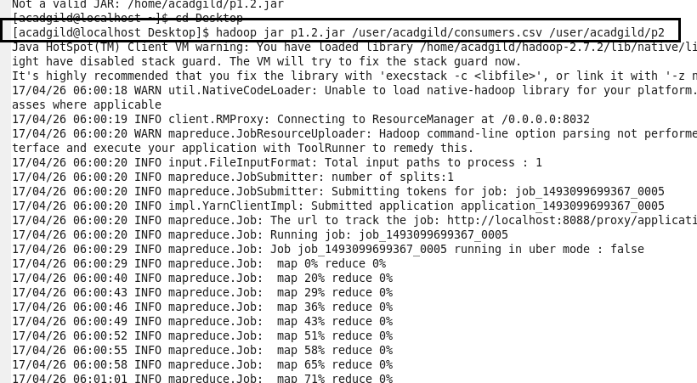

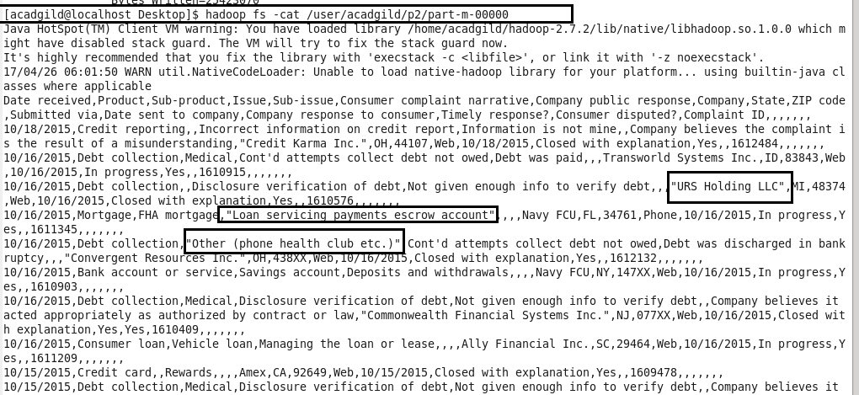

NOW USING GET COMMAND TO COPY TO LOCAL FOR DOING PIG

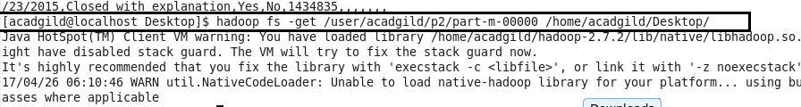

1. Write a pig script to find no of complaints which got timely response.

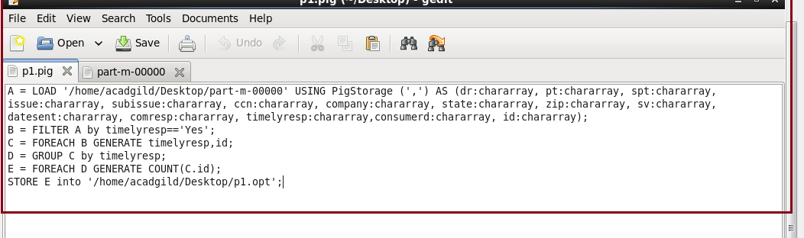

Output1

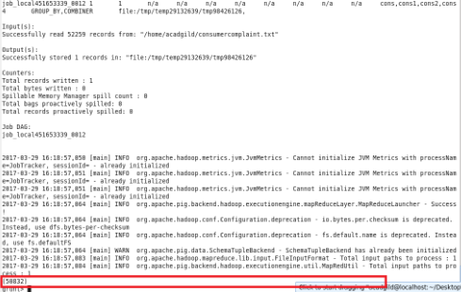

1. Write a pig script to find no of complaints where consumer forum forwarded the complaint same day they received to respective company.

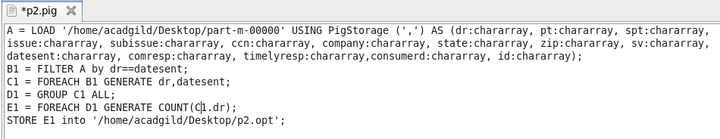

Output2

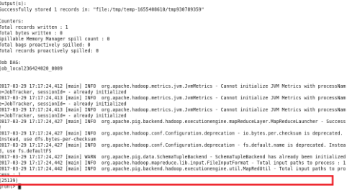

1. Write a pig script to find list of companies topping in complaint chart (companies with maximum number of complaints).

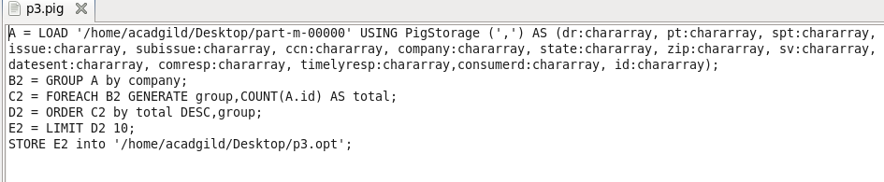

Output3

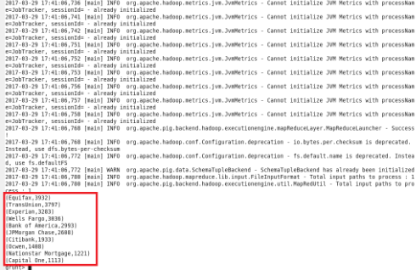

1. Write a pig script to find no of complaints filed with product type has “Debt collection” for the year 2015.

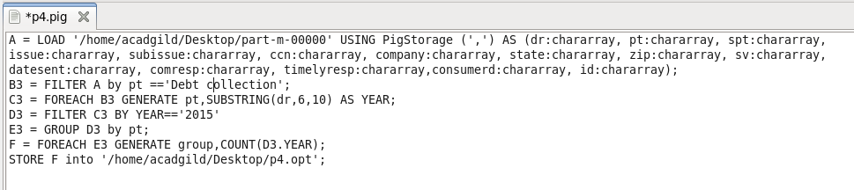

Output4

